Hendecagrammic Rotunda
# Source: AI Source: Provided by: [Data Path: Persons Table -> ID Column: 1, Name_En Column: Motasem Essam] -> From: [ChatGPT] on [7/25/2026]
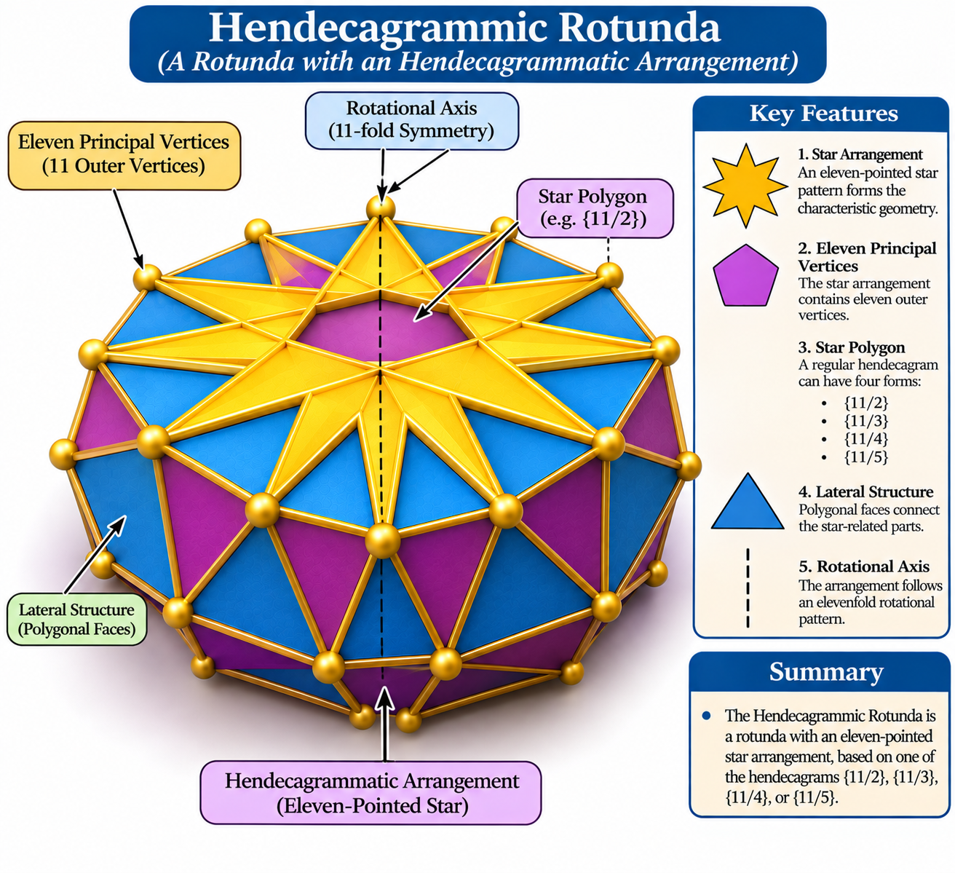

Definition
# Source: AI Source: Provided by: [Data Path: Persons Table -> ID Column: 1, Name_En Column: Motasem Essam] -> From: [ChatGPT] on [7/25/2026]
A Hendecagrammic Rotunda is a named member of the Star-Rotunda family, characterized by a hendecagrammatic arrangement (an eleven-pointed star).
It is listed alongside the Pentagrammic, Heptagrammic, and Enneagrammic Rotundas as one of the four named Star-Rotunda variants. <Cite refs={["turn316643search12","turn316643search1"]}/>
The term hendecagrammic refers to a star polygon with eleven vertices. Unlike an ordinary Hendecagonal Rotunda, its defining arrangement uses star-polygon geometry.

Geometric Structure
# Source: AI Source: Provided by: [Data Path: Persons Table -> ID Column: 1, Name_En Column: Motasem Essam] -> From: [ChatGPT] on [7/25/2026]
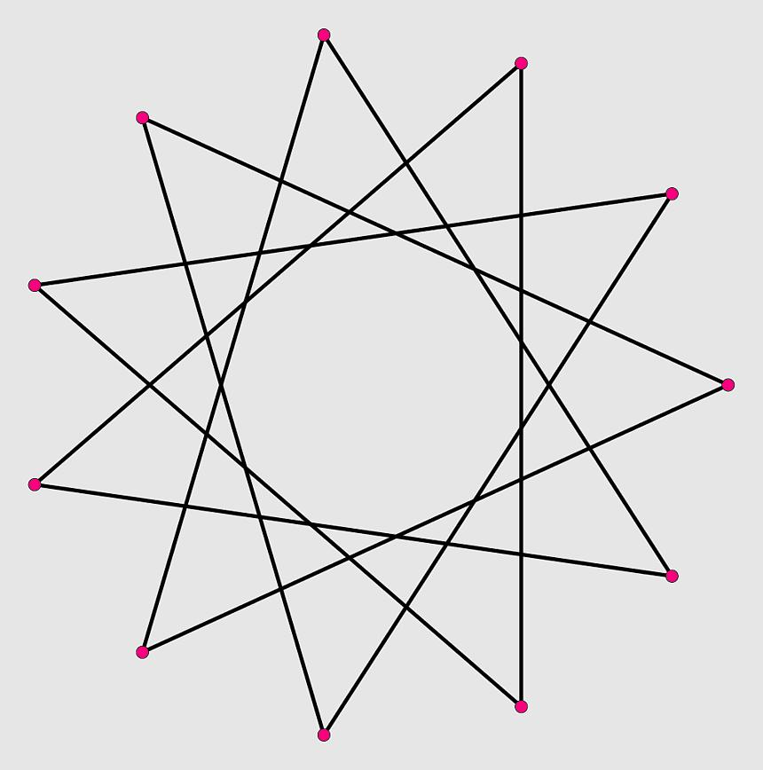
Its defining geometric feature is the hendecagrammatic arrangement:
- Star Arrangement: An eleven-pointed star pattern forms the characteristic geometry.
- Eleven Principal Vertices: The star arrangement contains eleven outer vertices.
- Star Polygon: A regular hendecagram can have four distinct forms:
- $\{11/2\}$
- $\{11/3\}$
- $\{11/4\}$
- $\{11/5\}$
- Lateral Structure: Polygonal faces connect the star-related parts of the three-dimensional construction.
- Rotational Axis: The arrangement follows an elevenfold rotational pattern.
The exact three-dimensional face arrangement depends on the particular construction and selected hendecagram. <Cite refs={["turn316643search17","turn316643search2"]}/>

Geometric Characteristics
# Source: AI Source: Provided by: [Data Path: Persons Table -> ID Column: 1, Name_En Column: Motasem Essam] -> From: [ChatGPT] on [7/25/2026]
- Solid Type: Star-Rotunda-type polyhedron.
- Defining Polygonal Arrangement: Hendecagram.
- Principal Vertices: 11.
- Star Polygon Notations: $\{11/2\}$, $\{11/3\}$, $\{11/4\}$, and $\{11/5\}$.
- Rotational Pattern: Elevenfold arrangement.
- Geometric Nature: Star-shaped construction.
- Convexity: May involve non-convex or intersecting geometry, depending on the model.
- Face Composition: Depends on the specific three-dimensional construction.
- Mathematical Counts: No universal face, edge, or vertex counts are established for all possible constructions.

Construction of Hendecagrammic Rotunda

Geometric Instruments Used
# Source: AI Source: Provided by: [Data Path: Persons Table -> ID Column: 1, Name_En Column: Motasem Essam] -> From: [ChatGPT] on [7/25/2026]
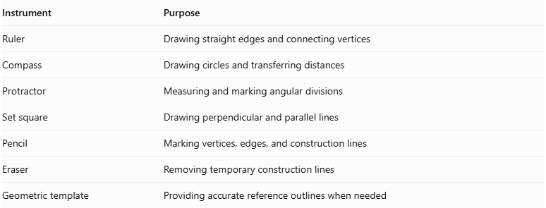
Instrument | Purpose
Ruler | Drawing straight edges and connecting vertices
Compass | Drawing circles and transferring distances
Protractor | Measuring and marking angular divisions
Set square | Drawing perpendicular and parallel lines
Pencil | Marking vertices, edges, and construction lines
Eraser | Removing temporary construction lines
Geometric template | Providing accurate reference outlines when needed

Instrument-Based Construction Procedures

Constructing the Regular Hendecagonal Reference
# Source: AI Source: Provided by: [Data Path: Persons Table -> ID Column: 1, Name_En Column: Motasem Essam] -> From: [ChatGPT] on [7/25/2026]
- Draw a circle using a compass.
- Mark its center $O$.
- Divide the circumference into eleven approximately equal angular sections using a protractor.
- Mark the eleven points $A,B,C,D,E,F,G,H,I,J,K$ in circular order.
- Check that the points are equally spaced around the circle.
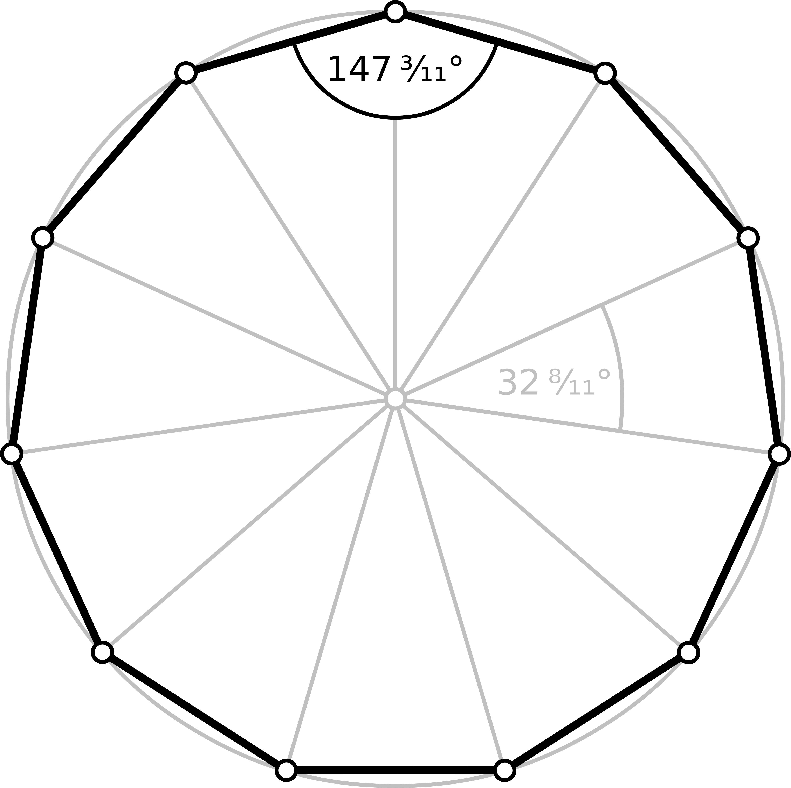
Angular measurement:
$$θ=\frac{{360}^{°}}{11}≈{32.7273}^{°}$$
Construction limitation: A regular hendecagon cannot be constructed exactly using only an unmarked straightedge and compass. A protractor or geometric template can be used for a measured or approximate construction.

Constructing the Hendecagram
# Source: AI Source: Provided by: [Data Path: Persons Table -> ID Column: 1, Name_En Column: Motasem Essam] -> From: [ChatGPT] on [7/25/2026]
The hendecagram has four regular forms. Each form uses the same eleven reference vertices but a different connection step.
A. Hendecagram $\{11/2\}$
- Start at vertex $A$.
- Connect $A$ to $C$.
- Continue connecting each vertex to the second next vertex.
- Follow the sequence until all eleven vertices have been connected.
- Close the star by returning to $A$.
B. Hendecagram $\{11/3\}$
- Start at vertex $A$.
- Connect $A$ to $D$.
- Continue connecting each vertex to the third next vertex.
- Follow the sequence until all eleven vertices have been connected.
- Close the star by returning to $A$.
C. Hendecagram $\{11/4\}$
- Start at vertex $A$.
- Connect $A$ to $E$.
- Continue connecting each vertex to the fourth next vertex.
- Follow the sequence until all eleven vertices have been connected.
- Close the star by returning to $A$.
D. Hendecagram $\{11/5\}$
- Start at vertex $A$.
- Connect $A$ to $F$.
- Continue connecting each vertex to the fifth next vertex.
- Follow the sequence until all eleven vertices have been connected.
- Close the star by returning to $A$.
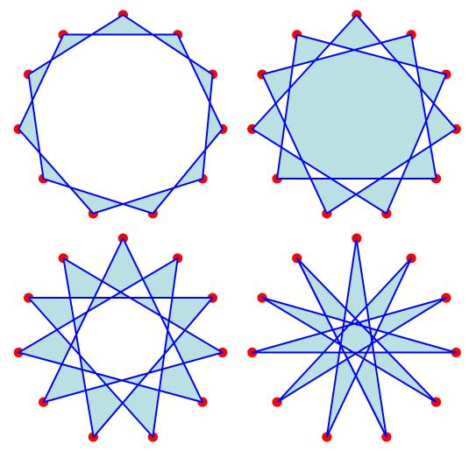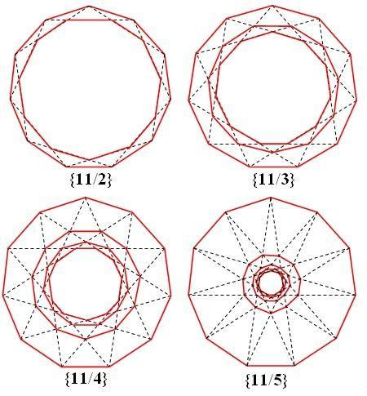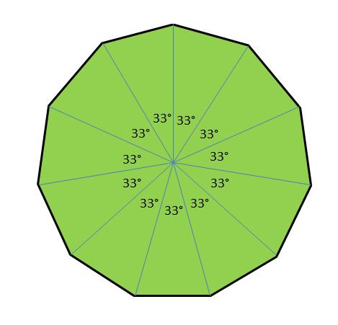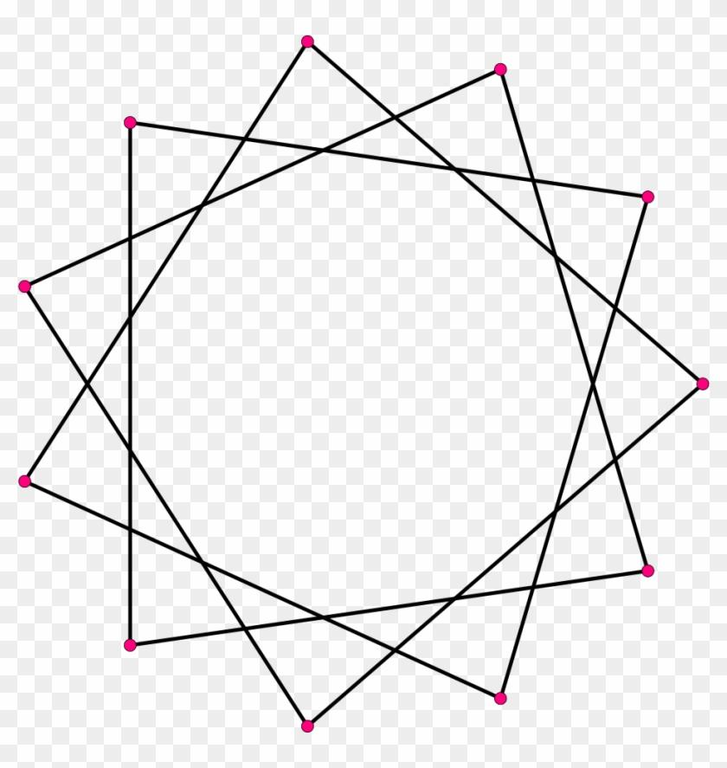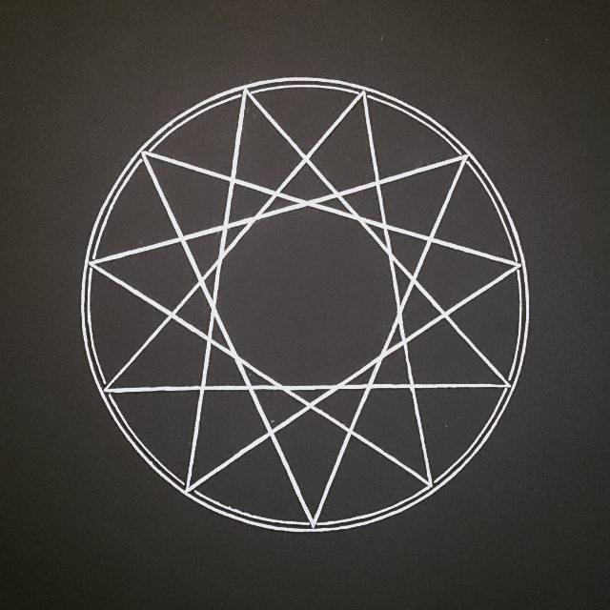
Connection-step measurements:
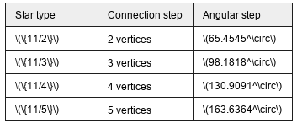
Star type | Connection step | Angular step
$$\{11/2\}$$ | 2 vertices | $${65.4545}^{°}$$
$$\{11/3\}$$ | 3 vertices | $${98.1818}^{°}$$
$$\{11/4\}$$ | 4 vertices | $${130.9091}^{°}$$
$$\{11/5\}$$ | 5 vertices | $${163.6364}^{°}$$
All four forms create continuous star polygons because eleven is prime.

Constructing the Parallel Arrangement
# Source: AI Source: Provided by: [Data Path: Persons Table -> ID Column: 1, Name_En Column: Motasem Essam] -> From: [ChatGPT] on [7/25/2026]
- Draw a second construction plane parallel to the first.
- Mark its center.
- Reproduce the eleven-point reference arrangement.
- Maintain the intended orientation and relative alignment between the two arrangements.
- Check the spacing and positioning of the corresponding vertices.

Establishing the Central Axis
# Source: AI Source: Provided by: [Data Path: Persons Table -> ID Column: 1, Name_En Column: Motasem Essam] -> From: [ChatGPT] on [7/25/2026]
- Identify the center of the upper arrangement.
- Identify the center of the lower arrangement.
- Draw a perpendicular line passing through both centers.
- Extend the line to represent the central axis.
- Use this axis as the reference for the solid's rotational arrangement.

Connecting the Upper and Lower Arrangements
# Source: AI Source: Provided by: [Data Path: Persons Table -> ID Column: 1, Name_En Column: Motasem Essam] -> From: [ChatGPT] on [7/25/2026]
- Identify the corresponding vertices in both arrangements.
- Connect the vertices according to the selected Hendecagrammic Rotunda reference model.
- Draw the required lateral edges using a ruler.
- Establish the boundaries of the lateral faces.
- Check that the connections reproduce the reference model without adding arbitrary edges.

Completing the Solid Representation
# Source: AI Source: Provided by: [Data Path: Persons Table -> ID Column: 1, Name_En Column: Motasem Essam] -> From: [ChatGPT] on [7/25/2026]
- Complete the upper and lower star-shaped boundaries.
- Complete the lateral face outlines.
- Draw visible edges using continuous lines.
- Draw hidden edges using dashed lines.
- Erase unnecessary construction lines.
- Label the star arrangements, lateral faces, vertices, and central axis.
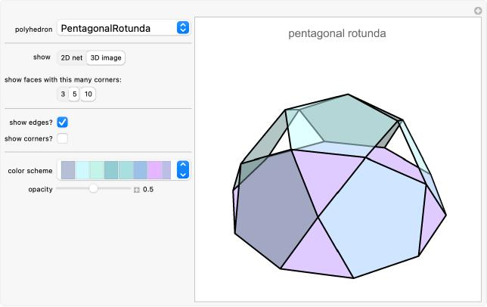

Key Points
# Source: AI Source: Provided by: [Data Path: Persons Table -> ID Column: 1, Name_En Column: Motasem Essam] -> From: [ChatGPT] on [7/25/2026]
- The Hendecagrammic Rotunda belongs to the Star-Rotunda family.
- Its defining arrangement is based on an eleven-pointed star.
- A regular hendecagram has four possible star-polygon forms.
- It is distinct from the ordinary Hendecagonal Rotunda.
- Its exact mathematical properties require a specified three-dimensional model.

Main Classification
# Source: AI Source: Provided by: [Data Path: Persons Table -> ID Column: 1, Name_En Column: Motasem Essam] -> From: [ChatGPT] on [7/25/2026]
Solid Geometry
└── Types of Solids
└── Star-Rotundas
└── Types of Star-Rotundas
└── Hendecagrammic Rotunda
└── Hendecagrammatic Arrangement
├── {11/2}
├── {11/3}
├── {11/4}
└── {11/5}

Conclusion
# Source: AI Source: Provided by: [Data Path: Persons Table -> ID Column: 1, Name_En Column: Motasem Essam] -> From: [ChatGPT] on [7/25/2026]
The Hendecagrammic Rotunda is a specialized Star-Rotunda characterized by an eleven-pointed star arrangement. Its defining two-dimensional geometry can be represented by four regular hendecagram forms, while its precise three-dimensional face composition depends on the selected construction.
Classification distinction: A Hendecagrammic Rotunda is different from a Hendecagonal Rotunda: the former uses star-polygon geometry, while the latter uses an ordinary convex hendecagonal base.

